*Egg Hunt*

Functional Specifications

Version: 1.0

<*25.03.2018*>

**Prepared by: Florian Brandsma, Jaakko Lankila, Erik Maresia**

Revision Chart

This chart contains a history of this document’s revisions. The entries below are provided solely for illustration purposes. Those entries should be deleted until the revision/s they refer to have actually been created.

The document itself should be stored in revision control, and a brief description of each version should be entered in the Revision Control System. A brief description can be repeated in this section. Revisions need not be described elsewhere in the document, unless they explain the document.

| Version | Primary Author(s) | Description of Version | Date Completed |
| --- | --- | --- | --- |
| *Draft* | Veijo Väisänen | Initial draft created for distribution and review comments | 21.1.2016 |
| *Preliminary* | Veijo Väisänen | Second draft incorporating initial review comments, distributed for final review | 12.2.2016 |
| *Final* | Veijo Väisänen | First complete draft, which is placed under change control | 1.3.2016 |

Contents

New paragraphs formatted as Heading 1, Heading 2, and Heading 3 will be added to the table automatically. To update this table of contents in Microsoft Word, put the cursor anywhere in the table and press F9. If you want the table to be easy to maintain, do not change it manually.

1. Introduction 5

1.1 Project Overview 5

1.2 Problem Statement 5

1.3 Reference/ Source Documents 5

1.4 Goals 5

2. System Architecture 6

2.1 System Architecture Diagram 6

3. Use Case Model 7

3.1 List of Actors 7

3.2 List of Use Cases 7

3.3 Use Case Diagram 8

3.4 Use Case Buy Item 9

3.5 System Sequence Diagrams 10

3.6 User Interface 11

3.7 Data Dictionary 11

4. Glossary 12

5. Appendices 13

List of Figures

New figures that are given captions using the Caption paragraph style will be added to the table automatically. To update this table of contents in Microsoft Word, put the cursor anywhere in the table and press F9. If you want the table to be easy to maintain, do not change it manually.

This section can be deleted if the document contains no figures or if otherwise desired.

Figure 1 System Architecture 6

Figure 2 System Level Use Case Diagram 7

Figure 3 The front page with menu open 9

Figure 4 Login page 10

# Introduction

## Project Overview

The objective of the project is delivering the user a browser-based game with working user log-in database, and a working administrator system.

## Problem Statement

The purpose of this project is learning to develop a game in a group of 3 people, following the waterfall model. The problems along the way will be dealt carefully with black-box testing.

## Reference/ Source Documents

The documents will include:

* Project plan
* Function plan
* Test report

## Goals

The goal of the project is to develop a game that supports one or more human players, that is run as a web-based application. The player has options to register a new user, log in as created user, play the game, change game settings, see the leaderboard and graphs. An administrator account is also created for managing the game’s database.

# System Architecture

The game and user information are stored in a MySQL Database. The data is retrieved from the database by the web server and is displayed to the user. Interactions with the web server by the user is sent to the database.

## System Architecture Diagram

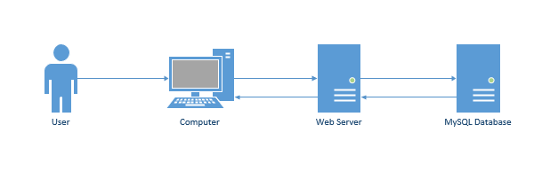

Figure 1 System Architecture

# Use Case Model

## List of Actors

Player; this person executes all the game interactions

Admin; this person monitors and suspends misbehaving users

## List of Use Cases

Play Session; main state of the game where all interactions are performed

Identify User; Play Session requires a valid user to be logged in

Create User; allows Player to create a new user

Login; allow player to provide account information and access the Play Session

Admin Session; allows the admin to monitor the users

Ban User; suspends a user for a given time

## Use Case Diagram

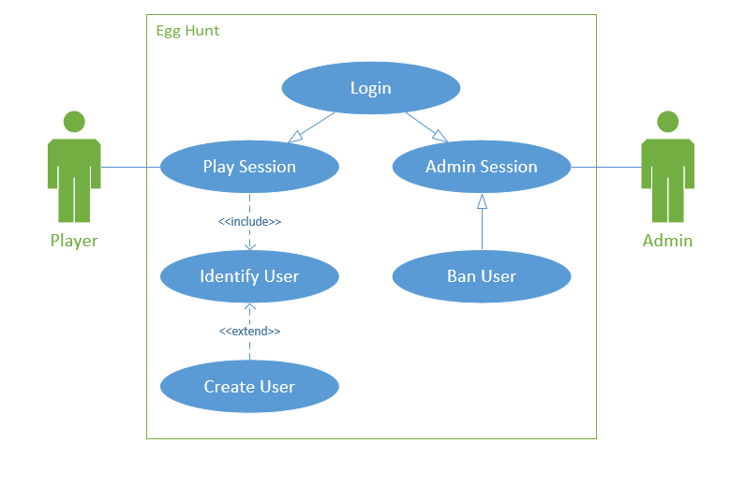

Figure 2 System Level Use Case Diagram

## Use Case Play Session

|  |  |  |  |  |  |  |
| --- | --- | --- | --- | --- | --- | --- |
| Section: Main | |  | | | | |
| Name: | | Play Session | | | | |
| Actors: | | Player | | | | |
| Purpose: | | Main state of the game where all interactions are performed | | | | |
| Description: | | A player may use their user credentials to engage in a play session with other players. The game is played in this state | | | | |
| Cross References: | | Use Cases: player must have completed the Login use case | | | | |
| Pre-Conditions | | The server is online with available capacity. | | | | |
| Successful Post-Conditions | | The game in Play Session receives player information from the server | | | | |
| Failure Post-Conditions | | Servers are full/offline, and the user is informed | | | | |
|  | |  | | | | |
| Typical Course of Events | | | | | | |
| Actor Action | | | | | System Response | |
| 1 | This use case begins when a player starts the game | | | |  |  |
| 2 | The browser will ask the player for user login credentials | | | | 3 | Start Login Use Case |
| 4 | ... | | | | 5 | ... |
| 7 | Player traverses the game world | | | | 8 | Push position to database |
| 9 | Player collects an egg | | | | 10 | Push score to database |
|  |  | | | | 11 | Update egg data in database |
|  | | | |  | | |
| Alternative Course | | | |  | | |
| Step 7: | | | | Player loses internet connection. Quit Play Session | | |
| Section: Login | | | |  | | |
| Typical Course of Events | | | |  | | |
| Actor Action | | | | | System Response | |
| 1 | The player is asked for their user credentials | | | |  |  |
| 2 | The user fills in their user credentials | | | | 3 | System identifies the user |
| 4 | Play Session is started | | | |  |  |
| Alternative Courses | | |  | | | |
| Step 3a: | | | System could not identify the user. | | | |
| Step 3b: | | | The user is notified of the error. | | | |

## System Sequence Diagrams

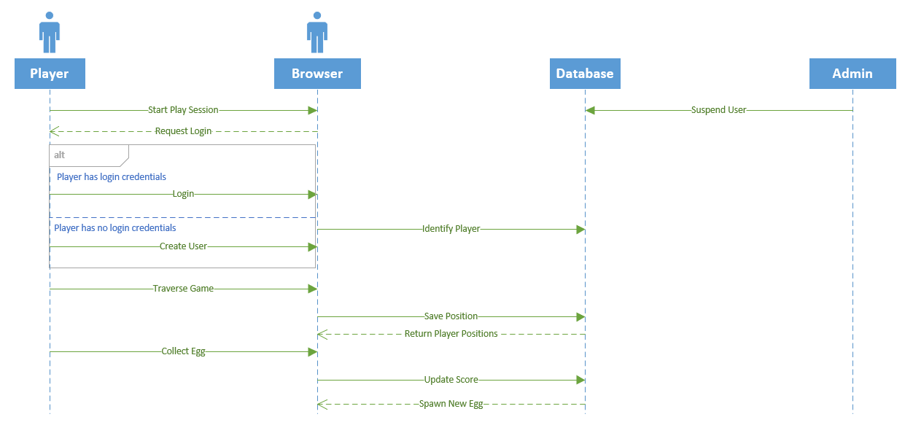

## User Interface

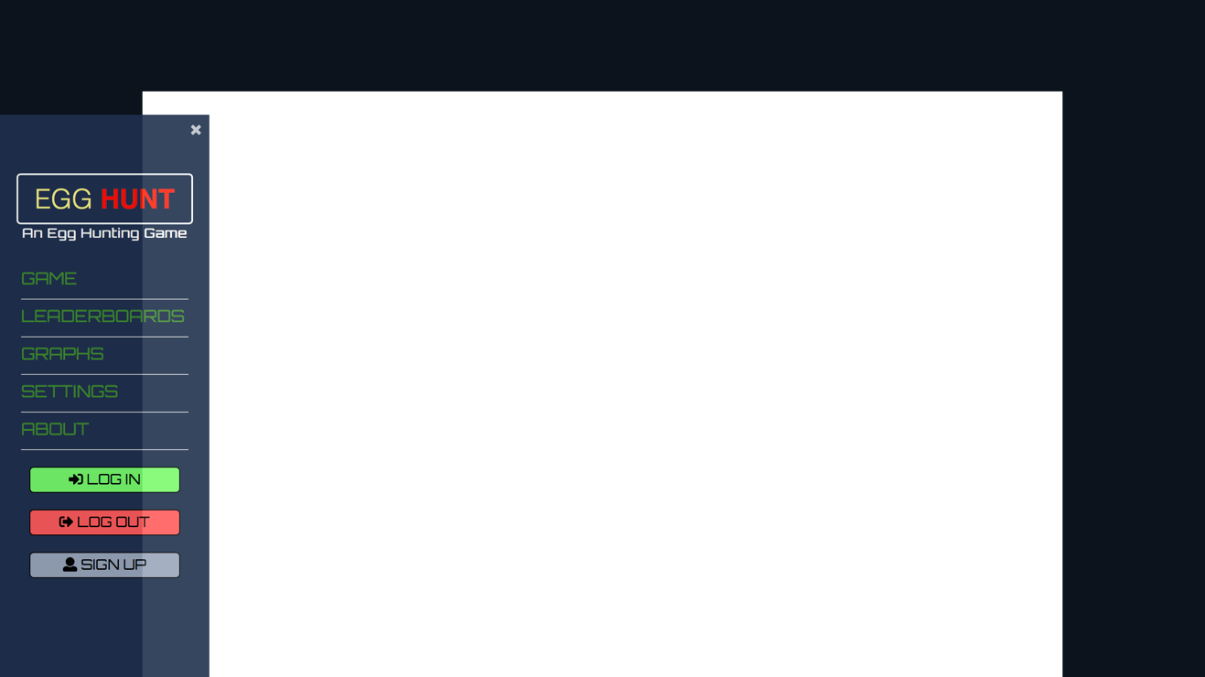

Figure 3 The front page with menu open

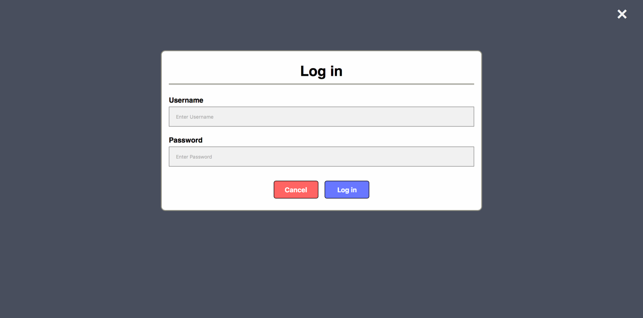

Figure 4 Login page

## Data Dictionary

|  |  |  |  |  |
| --- | --- | --- | --- | --- |
| Element Name | Type | Validation | Mandatory | Remarks |
| Login Page | Form |  | Yes |  |
| Menu | Navigation bar |  | No | Hides when closed. Executed with jQuery |
| Game | Canvas |  | Yes | Contains the actual game in a HTML canvas. The canvas is rendered via P5.JS |

# Glossary

|  |  |
| --- | --- |
|  | Comments |
| *Canvas* | *A HTML element in which Javascript draws into.* |
| *MySQL* | *A relational database management system* |
| *jQuery* | *Javascript library. Simplifies Javascript syntax.* |
| *P5.JS* | *Javascript library simplifying canvas scripting.* |
| *Web-based application* | *A program that runs in the browser* |
| *Black-box testing* | *Specification-based testing* |

# Appendices